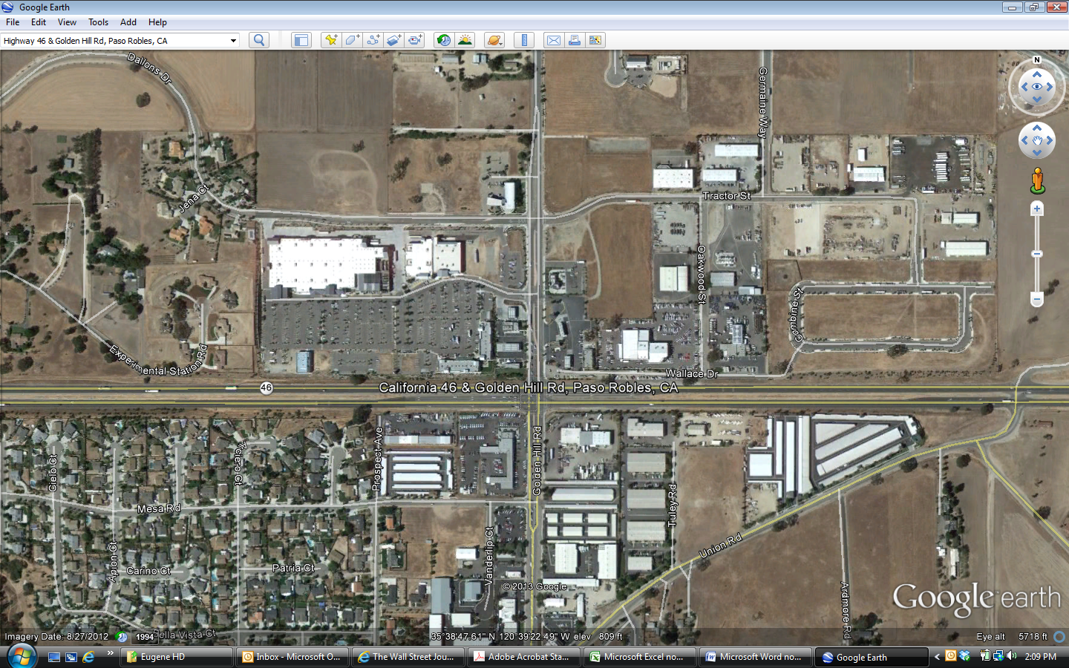

***Golden Hills Plaza***

Lowe’s Home Improvement

Bed, Bath & Beyond

America’s Tire

UPS Store